# Natural Stupidity is more Dangerous than Artificial Intelligence 自然的愚蠢比人工智能更危险

原文链接：  
原文链接：

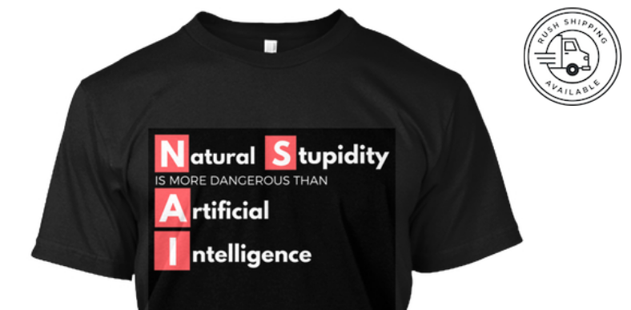

img  
img公司

Support my writing by treating yourself with a t-shirt:   
用t恤来支持我的写作：

Do you know what’s more dangerous than artificial intelligence? Natural stupidity. In this article, I will explore natural stupidity in more detail and show how our current technology (driven by narrow artificial intelligence) is making us collectively dumber.  
你知道什么比人工智能更危险吗？天生的愚蠢。在本文中，我将更详细地探讨自然愚蠢，并展示我们当前的技术（由狭义人工智能驱动）是如何使我们集体变得更愚蠢的。

We’ve all had this experience of using a GPS to guide us around an unfamiliar place only to realize later that we have no recollection or ability to get to that place again without the aid of a GPS. Not only is our directional instinct diminished because of lack of use, but so is our own memories. We’ve all experienced losing our ability to recall due to our over use of Google. We now recall more as to how we can search for something rather than the details of that something.  
我们都有过这样的经历：用GPS引导我们在一个陌生的地方转悠，后来才意识到，没有GPS的帮助，我们再也无法去那个地方了。我们的定向本能不仅因为缺乏使用而减弱，我们自己的记忆也是如此。我们都经历过由于过度使用谷歌而丧失召回能力的经历。我们现在回想的更多的是如何搜索某个东西，而不是那个东西的细节。

The framework that I often use to explore intuition is the found at Wikipedia. It’s a massive list of biases, however to get an overview of it, there are four high level categories that are the the drivers of theses biases. These are “Too Much Information”, “Not Enough Meaning”, “Need to Act Fast” and “What Should we Remember?”.  
我经常用来探索直觉的框架是在维基百科上找到的。这是一个庞大的偏见列表，但要得到一个概述，有四个高层次的类别，是这些偏见的驱动因素。这些都是“信息太多”、“意义不够”、“需要快速行动”和“我们应该记住什么？”？”.

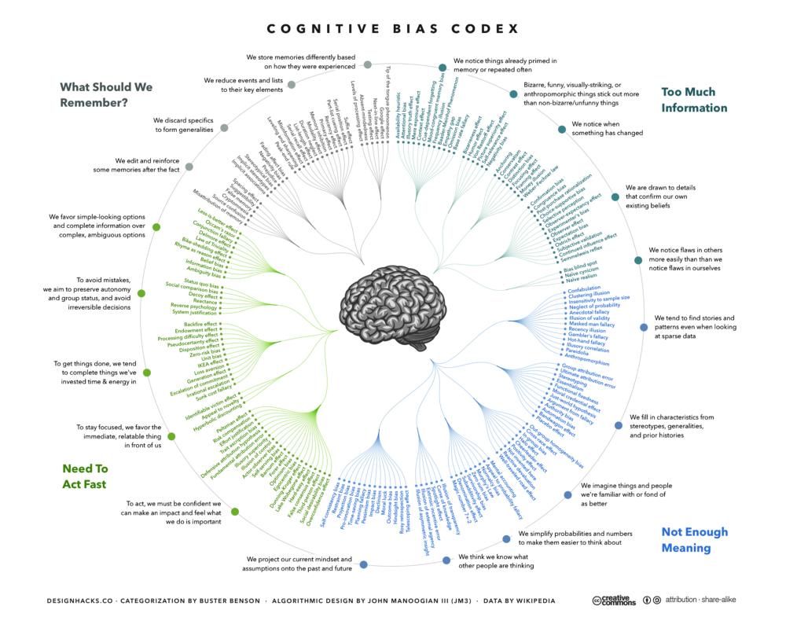

img  
img公司

Source:   
资料来源：

Our world requires more automation to run efficiently and sustainably. The products and services that will be in demand are the products that compensate for our inadequacies. The clear downside of this is that with every assist, the less we exercise our already weak facilities.  
我们的世界需要更多的自动化来高效和可持续地运行。我们需要的产品和服务是弥补我们不足的产品。这明显的缺点是，在每一次协助下，我们就越少使用我们已经很薄弱的设施。

The only people maintaining their smarts are the few people willing to constantly exercise their smarts. Meanwhile, we have a population that is becoming more out of shape and lazy with their own mental faculties. We imagine ourselves to being smarter because we can multi-task more. Yet, our brains have not evolved to do multi-tasking well. In fact, recent research have shown that pigeons have . It is just ironic that we’ve taken pride in our new found multi-tasking skills only to discover that we are dumber at it than pigeons!  
只有少数人愿意不断锻炼自己的聪明才智，才能保持自己的聪明才智。与此同时，我们的人口正变得越来越不健康和懒惰与他们自己的精神能力。我们想象自己变得更聪明，因为我们可以做更多的事情。然而，我们的大脑还没有进化到能很好地完成多项任务。事实上，最近的研究表明鸽子有。讽刺的是，我们对新发现的多任务处理技能感到自豪，却发现我们比鸽子更笨！

However, there is a far worse problem than automation making us dumber. The bigger problem is that other humans are aware that it can make us dumber and they are opportunistically exploiting our natural stupidity to influence our behavior. Over the decades, the industry of advertising has spend trillions of dollars inventing new ways to “motivate” us to do new things without us being aware of its influence. The techniques to do this neatly falls under the exploitation of our cognitive biases. After all, if we were indeed all perfectly logical, then we’ll likely spending our money in the most efficient way possible and very few companies will like us to do that. If we reduce our spending, our economies would stall and there would be an economic depression! (BTW, something is really wrong when we must accelerate our consumption so as to avoid economic stagnation)  
然而，还有一个比自动化更糟糕的问题让我们更蠢。更大的问题是，其他人意识到这会让我们变得更蠢，他们会机会主义地利用我们天生的愚蠢来影响我们的行为。几十年来，广告业花费了数万亿美元，发明了新的方式来“激励”我们做新的事情，而我们却不知道它的影响力。巧妙地做到这一点的技术属于我们认知偏见的利用。毕竟，如果我们确实都是完全合乎逻辑的，那么我们很可能会以最有效的方式花钱，很少有公司会喜欢我们这样做。如果我们减少开支，我们的经济就会停滞，经济就会萧条！（顺便说一句，在我们必须加快消费以避免经济停滞的时候，确实有些问题）

So, “Natural Stupidity” is basically our lack of meaning, lack of memory, inability to think fast and inability to process too much information. The current systems that we have in place provide products and services to substitute these inabilities. It is the natural tendency to seek out the method of least action. That is, the method that requires lest effort or the laziest thing that we can do. Let’s explore each of the four in greater detail.  
所以，“天生的愚蠢”基本上就是我们缺乏意义，缺乏记忆，不能快速思考，不能处理太多信息。我们现有的系统提供产品和服务来替代这些不可能。寻找最小作用的方法是自然的趋势。也就是说，这种方法需要我们尽可能少的努力或者做我们能做的最懒的事情。让我们更详细地研究一下这四个问题。

Humans from the beginning of the their life are driven to seek meaning. The simplest explanations to this are going to be the most natural appealing ones. Civilization will naturally create religion to not only create a necessary shared understanding of acceptable behavior but one that is driven by our need for meaning.  
人类从生命开始就被驱使去寻求意义。最简单的解释将是最自然的吸引人的解释。文明自然会创造宗教，不仅创造对可接受行为的必要的共同理解，而且创造一种由我们对意义的需求驱动的理解。

The written word (i.e. books) and its more advanced form, the world wide web are devices that address our limited memories. Memories require not only storage but also the capability of recall. Throughout history, religion and law has been transcribed in scrolls, books and now in automation (see: blockchain). Money is a form of memory, that is, once possession of it is a measure of one’s ability to acquire goods and services.  
书面文字（即书籍）及其更先进的形式，万维网是解决我们有限记忆的设备。记忆不仅需要储存，而且需要回忆能力。纵观历史，宗教和法律一直被记录在卷轴、书籍中，现在则被记录在自动化中（见：区块链）。金钱是记忆的一种形式，也就是说，一旦拥有了金钱，就可以衡量一个人获得商品和服务的能力。

Mankind created computers to automate the math that we invented. Computers not only store memories but are able to perform laborious and error-free computations. We find it an inconvenience to use cash in that we have to calculate in our minds the amount of change so as to guard against error or outright fraud. We have time keeping devices so that we don’t need to look out into the heavens to determine the time of day. We have GPS devices to help us avoid reading a map and calculating a path to our destination.  
人类发明计算机是为了使我们发明的数学自动化。计算机不仅存储存储器，而且能够进行费力的无错误计算。我们发现使用现金很不方便，因为我们必须在头脑中计算出零钱的数量，以防止错误或完全的欺诈。我们有时间保持装置，这样我们就不需要观察天空来确定一天中的时间。我们有GPS设备来帮助我们避免阅读地图和计算到达目的地的路径。

Finally, we have the problem of information overload. Our knowledge driven economies have accelerated our consumption of information. However, our brains have not magically evolved to process this fire-hose of information. The device that we use to process more information are services that curate information and exhaust it out in more easily digestible forms. Today, social networks such as Twitter and Facebook have become our primary tools for curating and receiving new information about the world. It is dumfounding that the leaders of these two companies believe it is not in their charter to ‘police’ the contents that they help propagate. With great power comes great responsibility, unless it I guess if it affects the bottom line!  
最后，我们遇到了信息过载的问题。我们的知识经济加速了我们的信息消费。然而，我们的大脑并没有神奇地进化来处理这些信息。我们用来处理更多信息的设备是一种服务，它可以收集信息并以更容易消化的形式将其耗尽。如今，Twitter和Facebook等社交网络已成为我们管理和接收世界新信息的主要工具。这两家公司的领导人认为，他们的章程中没有规定要“监管”他们帮助宣传的内容，这是一种杜撰。伟大的力量带来伟大的责任，除非它影响到底线！

We collectively become dumber when we relinquish responsibility and accountability to the automation (or A.I.) that furnishes us with cognitive assistance.  
当我们把责任和责任拱手让给自动化（或人工智能）时，我们会变得更加愚蠢。

When we avoid questioning the positions of our religious leaders and ignore obviously repugnant behavior in defense of our own beliefs.  
当我们避免质疑我们的宗教领袖的立场，忽视明显的令人反感的行为来捍卫我们自己的信仰。

We avoid verifying our history and cling to untrue historical information to justify our beliefs. This is the case for Neo-Nazis and Confederates who would like to imagine a more benevolent and just past.  
我们避免核实我们的历史，坚持不真实的历史信息来证明我们的信仰。这是新纳粹和邦联的情况，他们希望想象一个更仁慈和刚刚过去。

We ignore common sense by following algorithms in enforcement of procedures. Like the United Airlines where a 70 year old doctor was assaulted and removed from an airline just because the crew blindly followed protocol instead of their own common sense.  
我们在执行过程中遵循算法而忽略了常识。就像美国联合航空公司（United Airlines）一样，一位70岁的医生仅仅因为机组人员盲目地遵守规定，而不是他们自己的常识，就遭到了袭击，并被驱逐出了一家航空公司。

Finally, we don’t hold accountable organizations that employ information overload in the form of massive disinformation to mold public opinion.

We shouldn’t be worried about Artificial Intelligence taking over the world. The more immediate, clear and present danger is that Natural Stupidity has taken over this world and we are seeing daily occurrences of this in our public discourse.

More on how intuition, human behavior and artificial intelligence are tightly related: